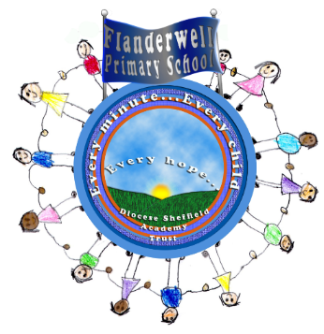
Flanderwell Primary School
Early Reading Policy 2021

Language Acquisition
At Flanderwell, we believe that communication and language provide the foundations for learning, thinking and wellbeing. A child’s core language acquisition occurs between one and four years old. During this time, children acquire phonology, syntax and vocabulary. Evidence indicates that success in literacy relies on the secure development of language and that these skills are amongst the best predictors of educational success.
We believe that effective environments support oral language. There is evidence that the rate at which children develop language is sensitive to the amount of input they receive from the adults and peers around them. The quality of this input is more important than the quantity. Ensuring all children experience effective language support requires a considered approach, appropriate to the needs of individual children, as well as staff training for good implementation.
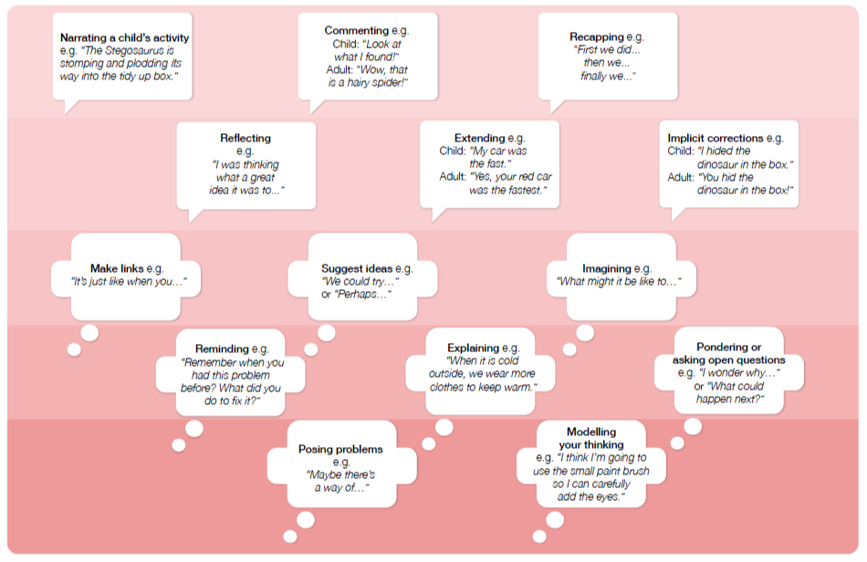
We believe that a language rich environment, beginning in FS1, is crucial. It is important that these language rich environments are intentionally planned for. By commenting on what children are interested in or doing and echoing back what they say with new vocabulary added, practitioners will build children’s language effectively. Where children share their ideas with support and modelling from their teacher, using sensitive questioning that invites them to elaborate, children become comfortable using a rich range of vocabulary and language structures. To improve children’s language acquisition and interaction when working with adults in the Foundation stage, our adults use the below documents to support them in planning intentionally. To support language acquisition in the Foundation stage, our adults use the below document to support them in planning intentionally, to improve the language of all of our children.
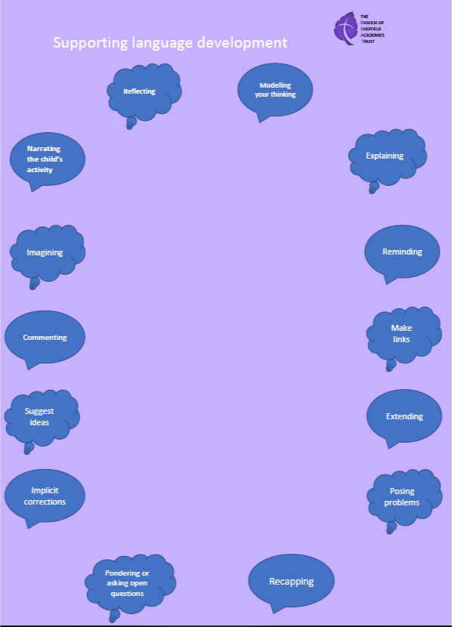

Read, Write, Inc Phonics
Children in our school learn to read and write effectively and quickly using the Read, Write, Inc Phonics programme. They progress onto Cracking Comprehension when they have completed the programme. Read, Write, Inc is a fast-paced, rigorous and structured phonics programme developed by Ruth Miskin. It helps to get every child reading fast and gives teachers the confidence and skills to deliver high-quality teaching every day.
The programme is for:
• Pupils in Foundation 2 to Year 2 who are learning to read and write
• Any pupils in Years 2, 3 and 4 who need to catch up rapidly
• Struggling readers in Years 5 and 6 follow Read Write Inc. Fresh Start.

In Read Write Inc. Phonics, pupils:
- Decode letter-sound correspondences quickly and effortlessly, using their phonic
- knowledge and skills.
- Read common exception words on sight
- Understand what they read
- Constantly revisit sounds and words to ensure they are embedded.
- Read aloud with fluency and expression
- Write confidently, with a strong focus on vocabulary and grammar
- Spell quickly and easily by segmenting the sounds in words
- Acquire good handwriting.
In addition, we teach pupils to work effectively with a partner to explain and consolidate what they are learning. This provides the teacher with opportunities to assess learning and to pick up on difficulties, such as pupils’ poor articulation, or problems with blending or alphabetic code knowledge. We group pupils consistently, according to their progress in reading, rather than their writing. This is because it is known that pupils’ progress in writing will lag behind progress in reading, especially for those whose motor skills are less well developed.

In the Foundation stage, we emphasise the alphabetic code. Pupils rapidly learn sounds and the letter or groups of letters they need to represent them. Simple mnemonics help them to grasp this quickly. This is especially useful for pupils at risk of making slower progress. This learning is consolidated daily. Pupils have frequent practice in reading high frequency words with irregular spellings – common exception words.
We make sure that pupils read books that are closely matched to their increasing knowledge of phonics and the common exception words. This is so that, early on, they experience success and gain confidence that they are readers. Re-reading and discussing these books with the teacher supports their increasingly fluent decoding.

Alongside this, the teachers read a wide range of stories, poetry and non-fiction to pupils during ‘core learning’ story time.
Embedding the alphabetic code early on means that pupils quickly learn to write simple words and sentences. We encourage them to compose each sentence aloud until they are confident to write independently. We make sure they write every day. Pupils write at the level of their spelling knowledge. The quality of the vocabulary they use in their writing reflects the language they have heard in the books the teacher has read to them; they have also discussed what the words mean.

Our aim is for pupils to complete the phonics programme as quickly as possible. The sooner they complete it, the sooner they will be able to choose books to read at their own interest and comprehension level.

Outcomes for children Assessing and tracking progress
We assess all pupils following Read Write Inc. Phonics using the Entry Assessment and subsequent assessments each half term. We use this data to assign them to either Read Write Inc. Phonics or Comprehension. This gives us a very good indication of how well they are making progress relative to their starting points. We do this for all pupils, whenever they join us, so we can track all of them effectively, including those eligible for the pupil premium. For those on the Read Write Inc. Phonics programme, we record their starting date and entry point on the tracker to monitor the rate at which they are making progress. We can also easily identify those who joined the programme later.

We aim for all children to be accurate and speedy readers by the time they enter Key Stage 2. We have high expectations of our pupils’ progress. Although we have been a Read, Write, Inc school for many years, we felt it necessary for our whole school staff to complete the new Read, Write Inc training. They did this on September 3rd 2021 and completed the RWI Get Writing training on November 4th 2021. We have already seen an impact on results and attribute this to the programme.

Pupils who are making slower progress usually complete the programme by the end of Year 2. We support pupils who have identified special educational needs for however long it takes until they can read. For example, we identify those who are at risk of falling behind their peers immediately – whatever their age. Highly trained staff tutor them for 10 minutes every day, using the Read Write Inc. One-to-one tutoring programme. If a child arrives in Key Stage 2 reading below their chronological age or with English as an additional language they are taught Read Write Inc. Phonics until they too catch up with their peers.

By the end of Key Stage 1, we aim for our pupils to be able to read aloud age-appropriate texts accurately and with sufficient speed for comprehension. This means that we can focus on developing their comprehension, preparing them well for transition to Key Stage 2. Their good decoding skills mean that they have a sound strategy for decoding unfamiliar words when they come across them at whatever stage or in any subject, even into secondary school.

Quality of teaching, learning and assessment
The programmes’ cycle of instruction means that, after direct instruction and guided practice, the pupils teach another pupil. In this way, they all rehearse and consolidate what they have been learning. This helps the pupils to make their understanding clear to themselves and helps the teacher deal with any misconceptions. ‘Partner teaching’ is a key assessment tool. We also use this approach effectively in other subjects.
In Read Write Inc. Phonics, because the pupils are grouped across the school in terms of their reading ability, they are reading at an appropriate decoding level every day. The consistent groups in the Phonic lessons help us to focus the teaching and ensure pupils learn to read quickly.
Assessments take place every six-eight weeks and children’s results are recorded on the trackers. This data allows us to intervene in different ways. For instance, we quickly move pupils to another group if they are progressing faster than their peers. Those who continue to struggle have one-to-one tutoring so that they keep up.
All the pupils are engaged, with a positive impact on their behaviour. We agree with them the rules for working in a group or discussing with a partner. We discourage ‘hands up’ for answering questions because we believe that all pupils should answer every question. The teacher selects pupils to answer. The Read Write Inc. programme contains detailed lesson plans. These give the teachers practical day-today
guidance, but we work hard to build on these plans so that the lessons are matched carefully to the needs of their particular group. Every activity is prepared thoroughly and has a clear purpose. The teacher explains this at the beginning so that the pupils understand, during the activity, what they are learning and why. Lessons are planned and prepared with the support of the Reading Leader.

Additional support for lower-attaining pupils learning to read
Pupils in the ‘lowest’ attaining group have the widest variety of needs. This is therefore the least homogeneous group. In order to give these pupils the same carefully targeted teaching as all the other groups, some of these pupils have daily one-to-one tutoring for 10 to 20 minutes, in addition to their group session in the morning. This tutoring helps us to meet their individual needs. Once these pupils have learnt to read they will receive additional support when learning to spell, which will be identified on their Individual Educational Plan.

Feedback and marking
We emphasise constructive feedback. For example, we praise pupils for how hard they work together to ensure that their learning is successful. We have clear systems for marking pupils’ work. Pupils know their teacher’s expectations for each activity. We mark activities with the pupils in the lesson and discuss the outcomes with the group and individuals so that the marking is genuinely used to take forward pupils’ learning.

Home Reading
In Foundation 1, children take home lilac books, to ensure they get the chance to practise language acquisition at home. Children also take home a ‘book for pleasure’, which is to be read to them by a grown up at home. We hope that these will both provide children with excellent opportunities to acquire language.
Towards the end of Foundation 1 and the beginning of Foundation 2, children will begin to take home RWI sound cards, so they get the chance to practise sounds learnt at home. When children can speedily and confidently orally blend Set 1 sounds, they will take home a sound blending book. As children move through the Read, Write, Inc programme, they will take home a phonically decodable book that is matched to their group on the programme. Children continue to take home a book for pleasure, to be read to them by their adult. When children have completed the RWI phonics programme, they will be assessed on the colour book band system and will take home the appropriate matched book.

Effectiveness of leadership and management
Shared vision
The school’s shared vision is that every pupil learns to read quickly and continues to read – widely and often. The headteacher- Julie Armitage- and reading leader- Holly Wain- work with all the staff to ensure that this happens. In particular, the headteacher and reading leader work together to monitor the quality of teaching. The Reading Leader provides regular coaching for staff (teachers and teaching assistants). The role of the reading leader is critical, as she drives the teaching of Read Write Inc. Phonics, ensuring that all pupils follow the programme consistently.

The reading leader’s roles include:
- ensuring that our teaching of reading is of the highest quality and that all our pupils make progress
- ensuring pupils in the ‘lower progress’ group are making good progress and organising one-to-one tutoring for the pupils who need extra support
-identifying children who need extra intervention for reading.
- keeping the groups homogeneous, i.e. at the same reading level
- providing further training (through masterclasses, coaching/ observation and face-to- face feedback).
- creating pathways on the training portal so that all reading teachers have access to training.
-supporting staff with lessons
-organising extra support for slower progress children.

The reading leader can give this support every day because she does not teach a group herself. Reading teachers alert the reading leader to any pupil whose progress is faster or slower than the rest of their group. The reading team is made up of a team of good teachers and teaching assistants (TAs) who each teach a group of pupils at the same reading level. Reading teachers are given two hours planning time weekly, to ensure they have sufficient time to plan, make resources and watch training videos. The reading leader is available for teaching assistants to ask any questions or to deliver training during this time.

Professional development
A key element of Read Write Inc. is consistent whole-school practice, underpinned by appropriate professional development. The headteacher, all the teachers and teaching assistants are trained to teach reading. All staff have attended Phonics training. We hold at least two Development Days every year to ensure we are aware of up-to-date practice. The reading leader and headteacher are in constant contact with the RWI consultant- Alice Moir. Together, they analyse the phonics trackers to identify children who are making insufficient progress. The RWI consultant supports the school with ways forward on how to ensure children catch up quickly and efficiently.

Virtual Classroom
For children who need extra phonics practice at home, we sent home Virtual Classroom links, to enable parents to practise with them. The links include speed sounds lessons for Set 1, 2 and 3 sounds, word time lessons, Fred games to support with oral blending and fluency activities. These all contribute to children making accelerated progress in reading.

Comprehension
When children have completed the Read, Write, Inc Phonics programme, they move into a comprehension group. At Flanderwell, Cracking Comprehension is taught and supplemented with Headstart comprehension.

